|  |  |
| --- | --- |
|  |  |

**Faculty of Technology and Engineering**

**U & P U. Patel Department of Computer Engineering**

Date: 01 / 12 / 2021

**Practical List**

|  |  |  |  |  |  |
| --- | --- | --- | --- | --- | --- |
| Academic Year | : | 2021-22 | Semester | : | 4 |
| Course code | : | CE259 | Course name | : | Programming in Python |

**Note: Practical List is for Students. We need to cover concept require to implement respective practical**

|  |  |
| --- | --- |
| **Sr. No.** | **Aim** |
|  | Installation & Configuration of Python(**3.6 or 3.7**) and Virtual Environment. Along with its all major editors, IDLE, Pycharm, Anaconda, Jupyter, Interpreter etc.  **Note: Do not install the latest version of python due to some backward compatibility issues.**  **Please take screenshots of each point mentioned in the assignment and upload .pdf file.** |

* + - 1. **Installation & Configuration Python(3.6 or 3.7)**

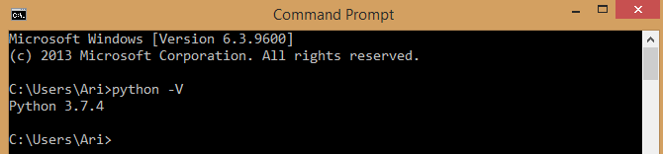

* + - 1. **Create virtual Environment using python -m command**

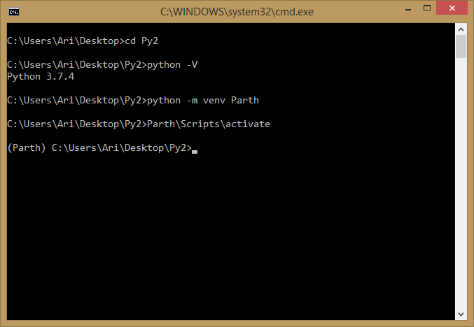

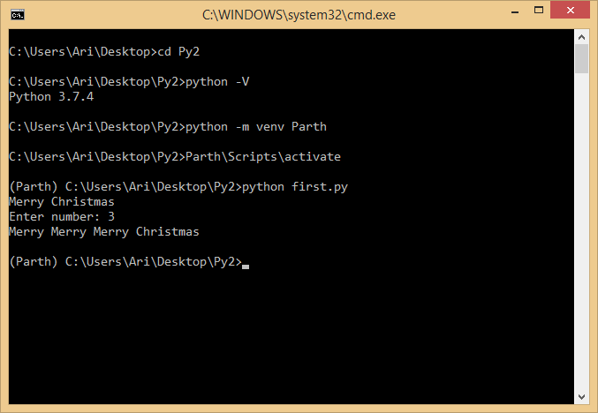  
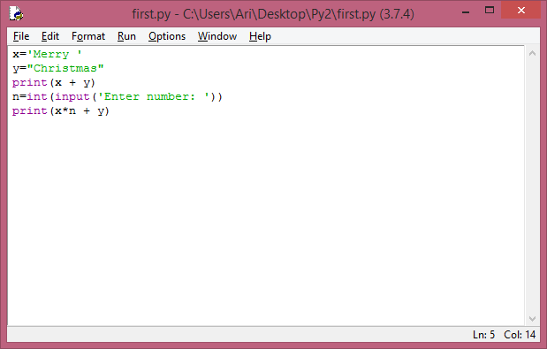

1. **Create virtual Environment using python package virtualenv and virtualwrapper.**

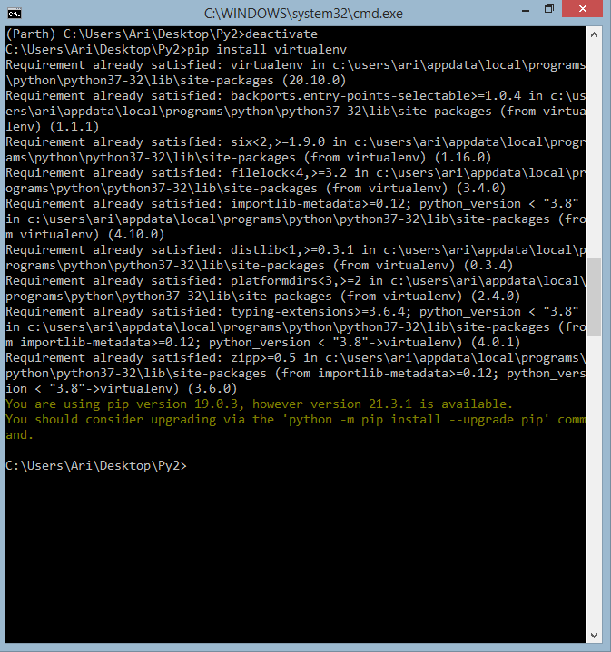

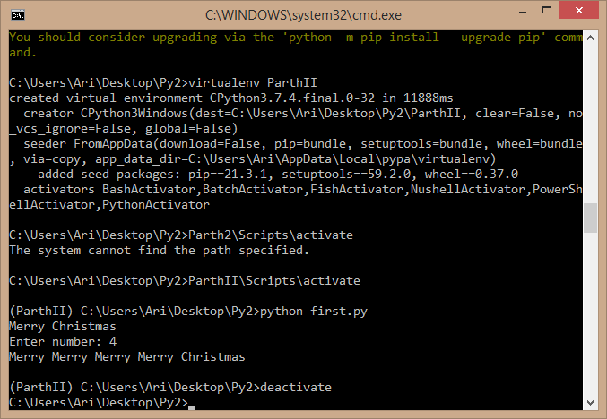

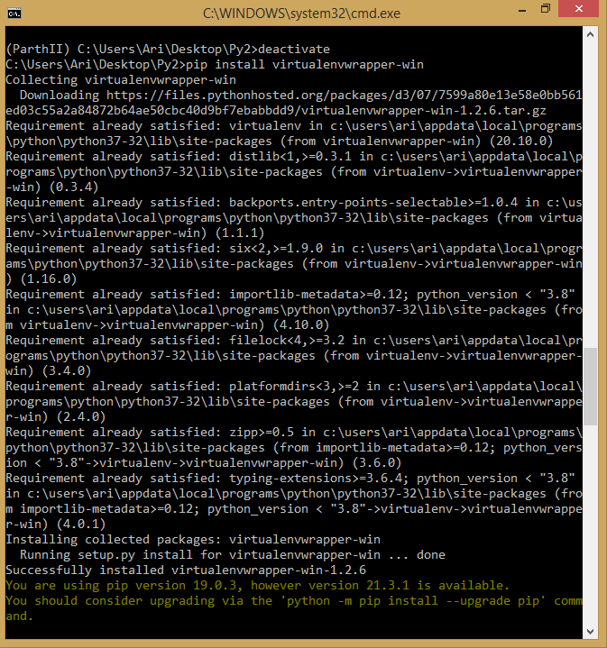

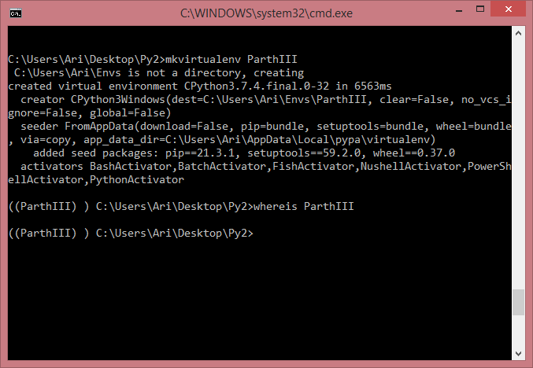

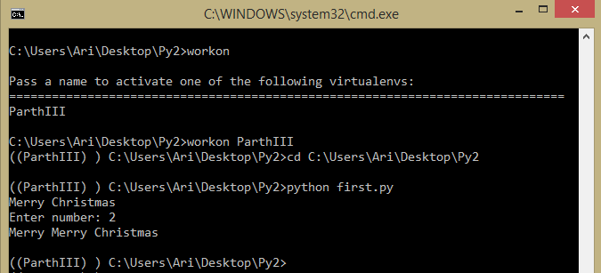

1. **Create virtual environment in Ananconda, PyCharm IDE and VS Code IDE. (All three IDE have to be installed by each students)(Assign to students as Homework)**

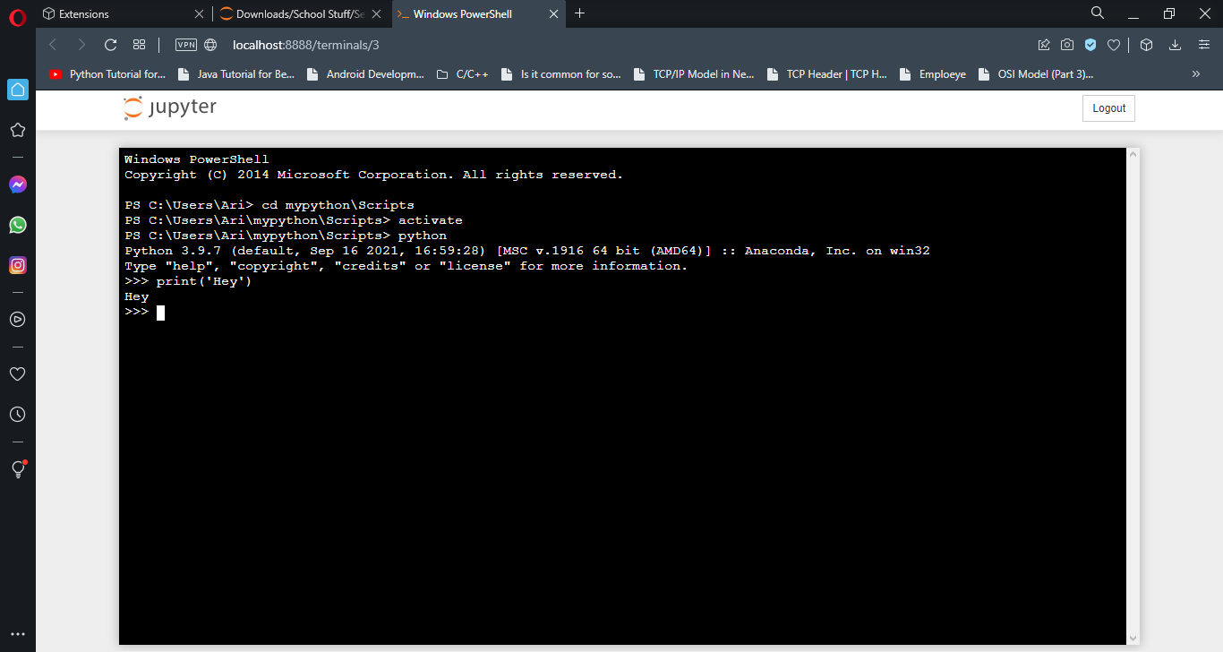

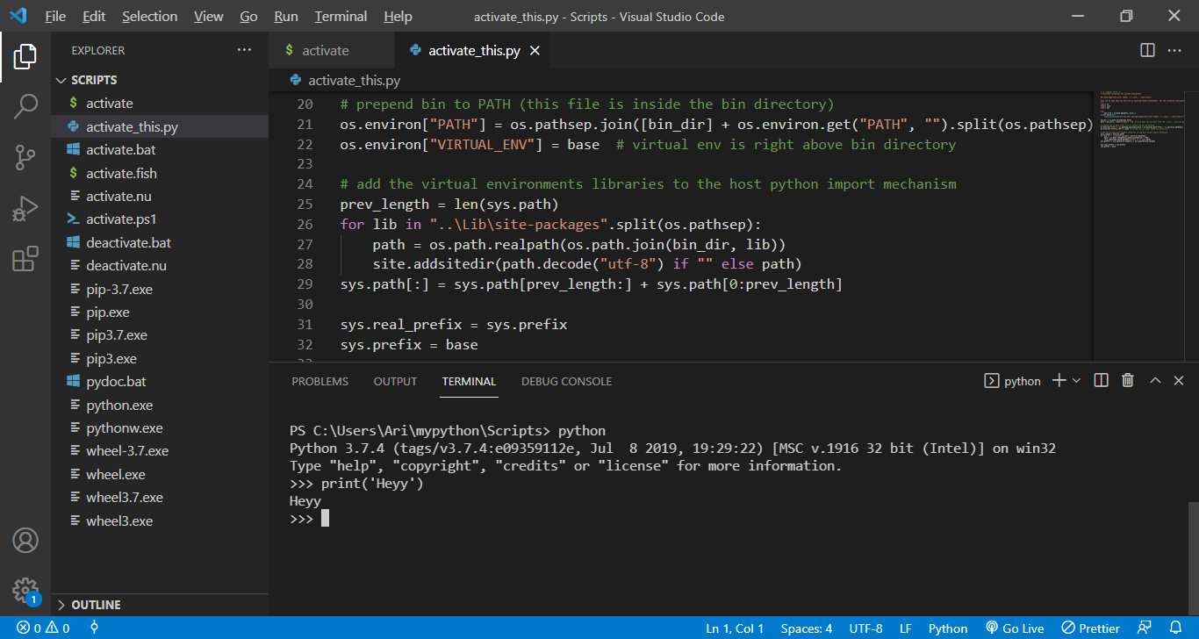

1. **List all virtual environment**

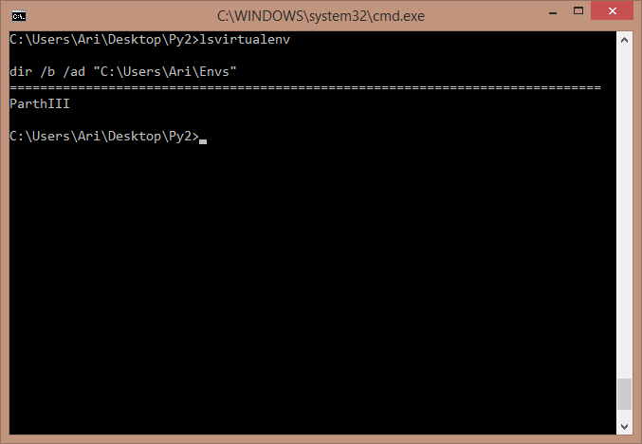

1. **Switch between virtual environment using activate and deactivate option.**

Demonstrated in Steps 2 & 3.